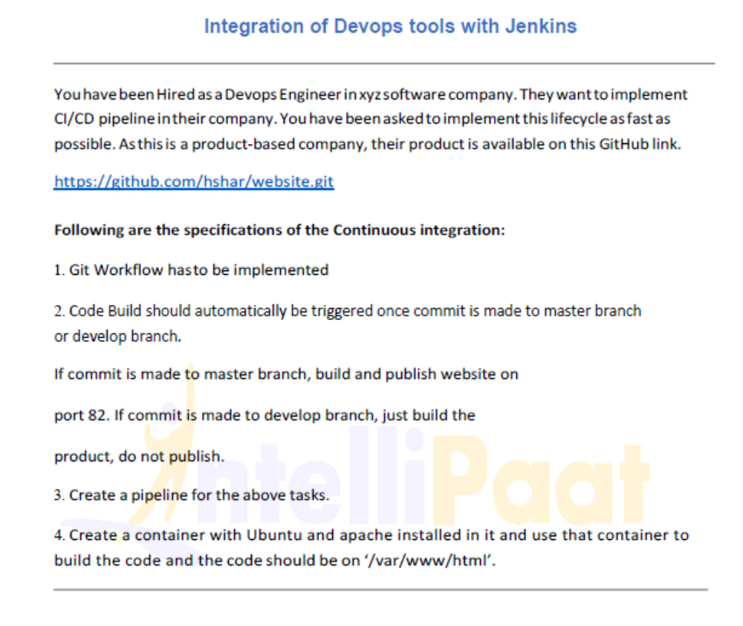
ubuntu@ip-172-31-30-81:~$ cd jenkins/
ubuntu@ip-172-31-30-81:~/jenkins$ ls
remoting workspace
ubuntu@ip-172-31-30-81:~/jenkins$ cd workspace/
ubuntu@ip-172-31-30-81:~/jenkins/workspace$ ls
Git-CS Git-job push-to-prod
ubuntu@ip-172-31-30-81:~/jenkins/workspace$ cd Git-CS
ubuntu@ip-172-31-30-81:~/jenkins/workspace/Git-CS$ ls
images index.html
ubuntu@ip-172-31-30-81:~/jenkins/workspace/Git-CS$
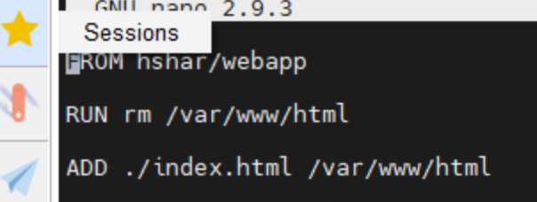
ubuntu@ip-172-31-30-81:~/website$ cat index.html
<html>
<head>
<title> Devops </title>
</head>
<body style = "background-image:url('images/github3.jpg'); background-size: 100%">
<h2 ALIGN=CENTER>Hello Devops world</h2>
</body>
</html>
ubuntu@ip-172-31-30-81:~/website$ sudo nano Dockerfile
ubuntu@ip-172-31-30-81:~/website$ sudo docker build . -t test
Sending build context to Docker daemon 3.072kB
Step 1/2 : FROM hshar/webapp
---> 0cbc1f535ed8
Step 2/2 : ADD ./index.html /var/www/html
---> fe35774bbb2a
Successfully built fe35774bbb2a
Successfully tagged test:latest
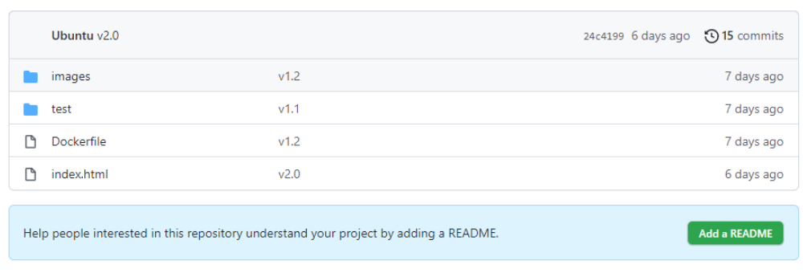

ubuntu@ip-172-31-30-81:~/website$ ls
Dockerfile images index.html test website
ubuntu@ip-172-31-30-81:~/website$ cd test
ubuntu@ip-172-31-30-81:~/website/test$ ls
Dockerfile images index.html
ubuntu@ip-172-31-30-81:~/website/test$ cd ..
ubuntu@ip-172-31-30-81:~/website$ sudo docker run -it -d ubuntu
Unable to find image 'ubuntu:latest' locally
latest: Pulling from library/ubuntu
7b1a6ab2e44d: Pull complete
Digest: sha256:626ffe58f6e7566e00254b638eb7e0f3b11d4da9675088f4781a50ae288f3322
Status: Downloaded newer image for ubuntu:latest
eef4b4bfa6c4ffb4f3d251b553b524175133e816287363bace5dbb3d51f9a876
ubuntu@ip-172-31-30-81:~/website$ sudo docker ps
CONTAINER ID IMAGE COMMAND CREATED STATUS PORTS NAMES
eef4b4bfa6c4 ubuntu "bash" 9 seconds ago Up 8 seconds eloquent_bouman
ubuntu@ip-172-31-30-81:~/website$ cd
ubuntu@ip-172-31-30-81:~$ cd jenkins/
ubuntu@ip-172-31-30-81:~/jenkins$ ls
remoting workspace
ubuntu@ip-172-31-30-81:~/jenkins$ cd workspace/
ubuntu@ip-172-31-30-81:~/jenkins/workspace$ ls
Build-website Git-CS Git-job push-to-prod
ubuntu@ip-172-31-30-81:~/jenkins/workspace$ cd Build-website/
ubuntu@ip-172-31-30-81:~/jenkins/workspace/Build-website$ ls
images index.html
ubuntu@ip-172-31-30-81:~$ cd jenkins/
ubuntu@ip-172-31-30-81:~/jenkins$ cd workspace/
ubuntu@ip-172-31-30-81:~/jenkins/workspace$ ls
Build-website Git-CS Git-job push-to-prod
ubuntu@ip-172-31-30-81:~/jenkins/workspace$ cd Build-website/
ubuntu@ip-172-31-30-81:~/jenkins/workspace/Build-website$ ls
Dockerfile images index.html test
ubuntu@ip-172-31-30-81:~/jenkins/workspace/Build-website$ cat Dockerfile
FROM hshar/webapp
ADD . /var/www/html/
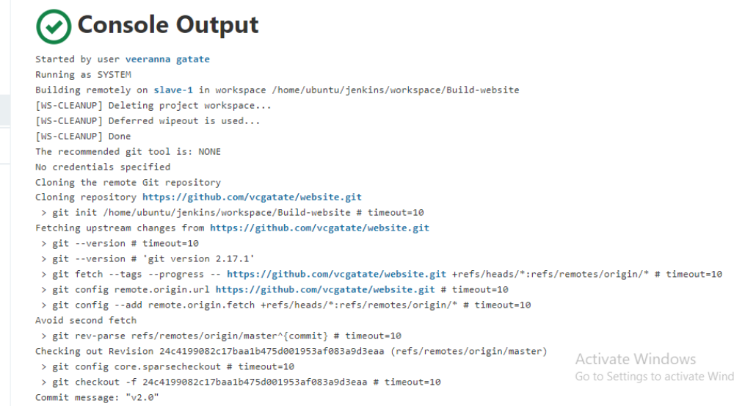
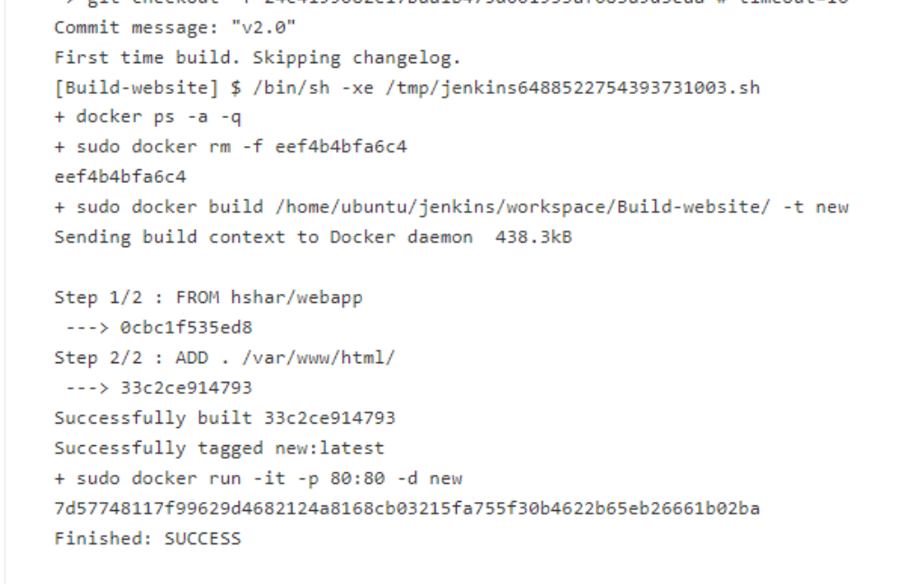



Building pipeline for build-website job

